Q1. How new was the session material to you?
1_____2_____3_____4_____5_____6_____7_____8_____9_____10
Not at all Very much

Q2. How easy was it to understand?
1_____2_____3_____4_____5_____6_____7_____8_____9_____10
Not at all Very easy

Q3. How well was it presented?
1_____2_____3_____4_____5_____6_____7_____8_____9_____10
Really bad Really good

Q4. How relevant was the material for you in your work?
1_____2_____3_____4_____5_____6_____7_____8_____9_____10
Not at all Very much

Q5. How would you describe the relevance of this course to other HomePlace staff who do similar work to you?
1_____2_____3_____4_____5_____6_____7_____8_____9_____10
Not at all relevant Very relevant
Please describe your current job role…………………………………………
(eg, RN, Support Worker, PMA, EN, Admin Officer, Team Leader, Manager, Librarian etc)

Q6. GENERAL FEEDBACK

I valued this:…………………………………………………………………..
…………………………………………………………………………………
…………………………………………………………………………………
…………………………………………………………………………………
………………………………………………………………………………….
I didn’t value this:………………………………………………………………
…………………………………………………………………………………..
…………………………………………………………………………………..
…………………………………………………………………………………..
…………………………………………………………………………………..
My overall comment about this workshop is:…………………………………………..
…………………………………………………………………………………..
…………………………………………………………………………………..
…………………………………………………………………………………..
…………………………………………………………………………………..
…………………………………………………………………………………..
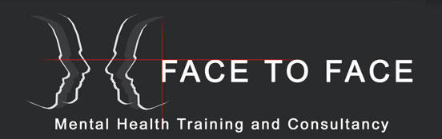
Name (optional):……………………………………………

Thank you

